Devops Day 8

Traffic goes high – number of services increases – scaling up

CI – build and create packages

CD – package has been deployed onto the prod server

This is a concept to explain how Kubernetes and docker swarm do. Kubernetes is more popular tool

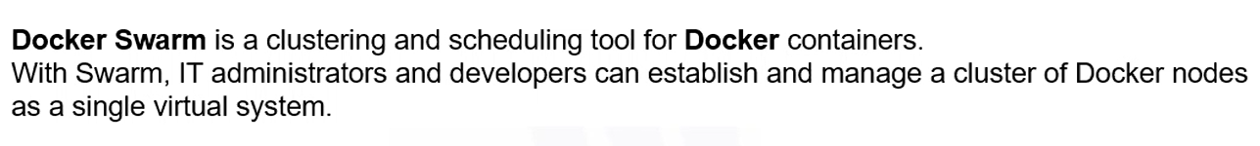

Leader – tell workers what to do,what to display for the users. Each worker is a VM for containers, sql container, apache container, other services container

Leader – will always be run by Kubernetes or swarm exe

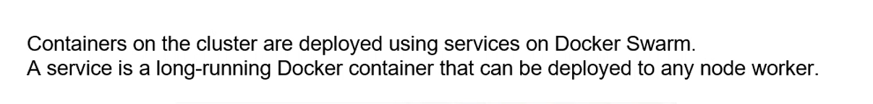

Replicas – like a cluster of services. If one service is down, the other two services still run

Two containers will not interact with one another

So docker network is set up

Homework: network docker tutorial

Docker swarm set up

Hands on – deploying a multi tier